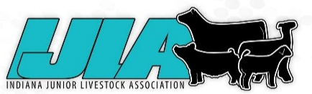
INDIANA JUNIOR LIVESTOCK ASSOCIATION
2025-26 Junior Board Application
Ages 14 - 21 as of January 1, 2026

Application due October 4th, 2025

Date ______________________ Do you have transportation to attend meetings and events ? ___________

Name ____________________________________________________ Birthdate ______________________

Address_________________________________________________________________________________

Parents _____________________________________ Email ______________________________________

Phone ___________________________

Year in School _________________ School attending ____________________________________________

Check the species you show or have an interest in - _____ Beef _____ Boer Goat ____ Sheep ____ Swine
_____ Other (list) __________________________________________________________________

Please answer the following questions.

1. Why would you like to serve on the IJLA Board of Directors?

2. What leadership roles have you served in other organizations? Please include volunteer activities you have
done as well as offices held.

.
3. What experience in the livestock industry has influenced you to want to be a part of the IJLA board?

4. What is an activity or program you would like IJLA to implement or improve on? It can be an original idea or
something that already exists that can be improved on

5. Check all the boxes that apply

Will attend 50% of the meetings – usually have 10, Zoom or in person
Will help with two Hoosier Elite Circuit Shows
Will help with at least two of the following –
- Hoosier Elite Swine Circuit Shows
- Hoosier Elite Beef Circuit Shows
- Hoosier Elite Beef or Swine Banquet
- Santa’s Swine Showdown

Signed by _________________________________________________________________________
Return by October 4th to:
INDIANA JUNIOR LIVESTOCK ASSOCIATION
P.O. Box 792 - Greenfield, IN 46140
Email - injrliveassn@gmail.com

